RAJAGIRI SCHOOL OF
ENGINEERING & TECHNOLOGY

RAJAGIRI VALLEY, KAKKANAD, COCHIN – 682 039

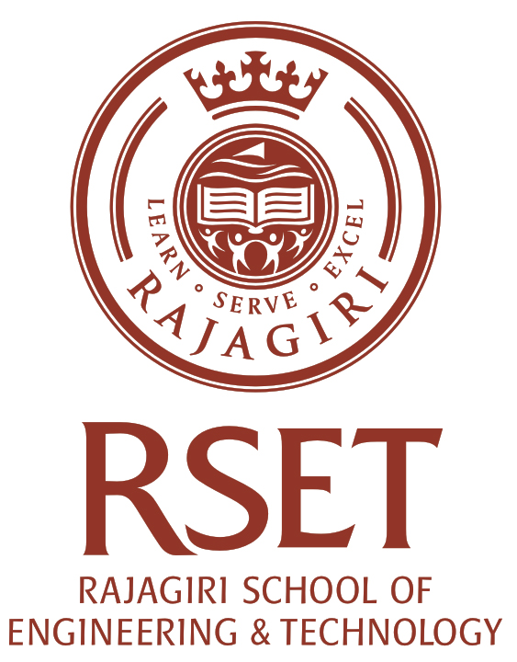

Certificate

Certified that this is a Bonafide Record of the Seminar on CUDA by ARUN BABY, university register number 372579 of branch Computer Science and Engineering during the Seventh semester in the year 2010 at Rajagiri School Of Engineering & Technology, Kakkanad, Kochi.

Seminar-In-Charge Head of the Department

